

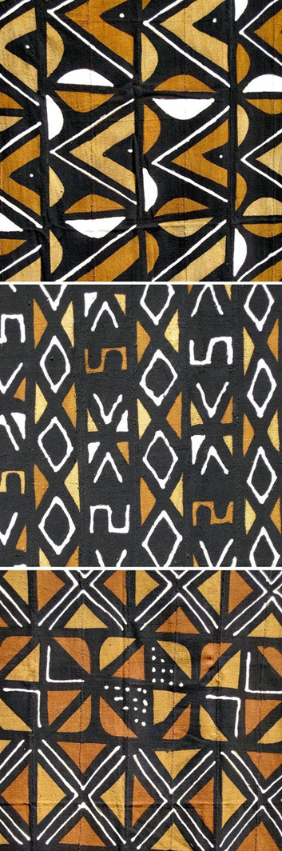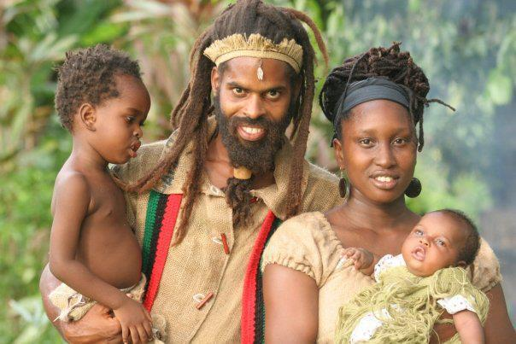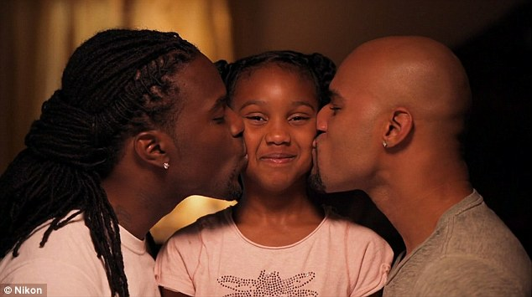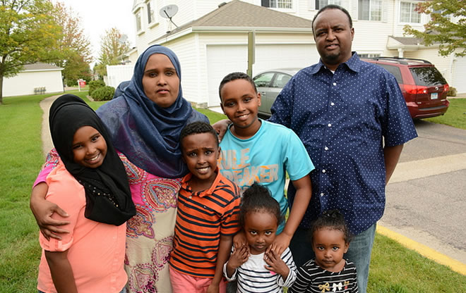

Presented in collaboration with the African Heritage Month Committee and the Parent and Community Engagement Office (PCEO)

**#thetalk**

Parents of African Descent, have you had the talk? The race/racism talk?

**Join us for a talk on:**

**How to talk to your child (ren) about race and racism**

**Date**: **Thursday February 08,**

**2018**

**Time: 6:30-8:30 pm,**

**Location**: 5050 Yonge Street

Boardroom